**Name: Abu Bakar Rasheed**

**Roll no: l1f23bsse0371**

**Nested queries and joins**

**______________________________________**

**Q:1**

select name, phoneNum

from customer AS c

inner join

loanaccounts AS l

on c.customer_id=l.customer_id where current_credit > 15000;

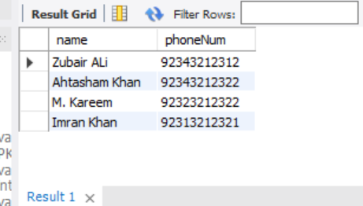

**Q:2**

select name, Address

from customer

where customer_id in

(select customer_id from loanaccounts

where name="Imran Khan");

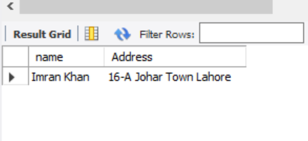

**Q:3**

select c.name, c.phoneNum, la.current_credit

from customer c

left join

loanaccounts la on c.customer_id = la.customer_id

where

la.current_credit is null;

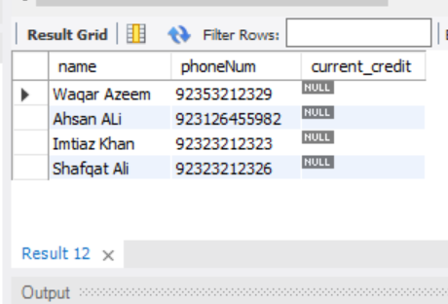

**Q:4**

select c.* from customer c

where c.customer_id in (

select la.customer_id

from loanaccounts la

)

and c.customer_id not in (

select sa.customer_id

from savingaccounts sa

);

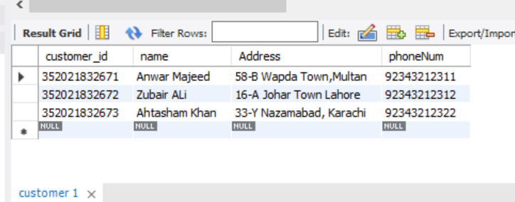

**Q:5**

select t.*,c.name AS customer_name, e.name AS salesman_name

from transaction t

join

loanaccounts la on t.loanAccount_number = la.Account_number

join

customer c on la.customer_id = c.customer_id

join

employee e on t.eid = e.eid;

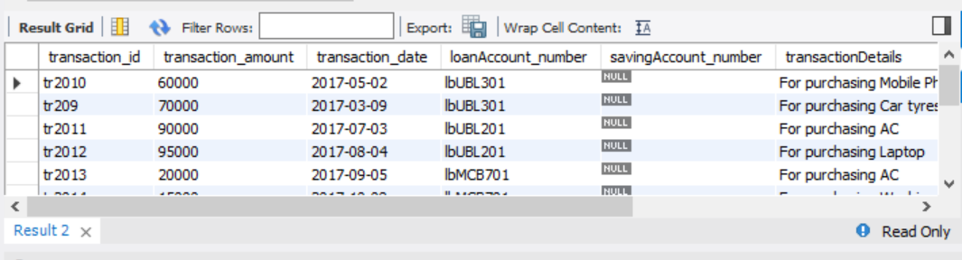

**Q:6**

select c.*, sa.*, branch_id

from customer c

join savingaccounts sa On c.customer_id = sa.customer_id

where c.customer_id in(select sa.customer_id from savingaccounts sa);

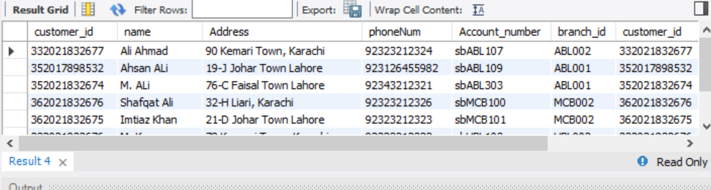

**Q:7**

select

c.name AS customer_name,

c.Address AS customer_address,

b.branch_address AS branch_address,

bk.bank_name AS bank_name

from customer c

join

savingaccounts sa on c.customer_id = sa.customer_id

join

branch b on sa.branch_id = b.branch_id

join

bank bk on b.bank_id = bk.bank_id;

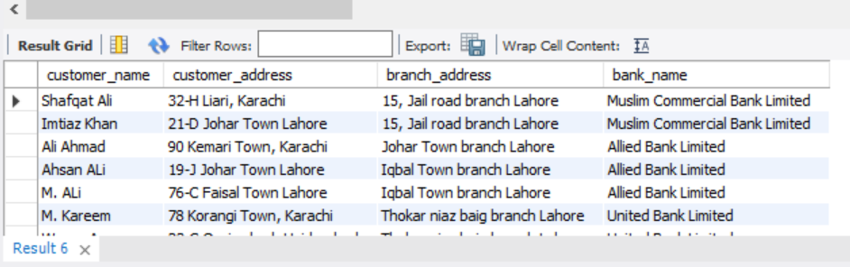

**Q:8**

select b.branch_id, b.branch_address

from branch b

where b.bank_id in (

select bk.bank_id

from bank bk

where bk.bank_name = 'Allied Bank Limited'

);

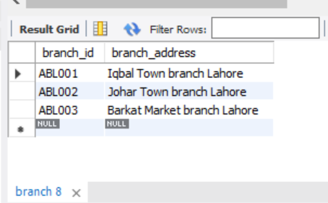

**Q:9**

select

e.name AS employee_name,

e.designation,

b.branch_address,

bk.bank_name

from employee e

right join

branch b on e.branch_id = b.branch_id

right join

bank bk on b.bank_id = bk.bank_id;

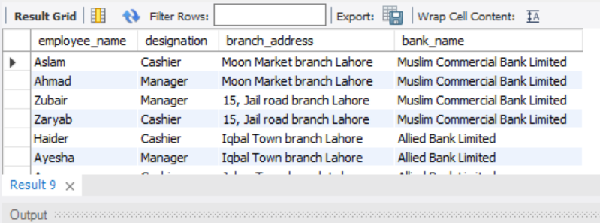

**Q:10**

select distinct b.branch_id

from branch b

where b.branch_id in (

select la.branch_id

from loanaccounts la

) and b.branch_id in (

select sa.branch_id

from savingaccounts sa

);

